

**YEAR 12 MATHEMATICS METHODS Test 4 2016**

Continuous Random Variable, Random sampling, Sample Proportions

## NAME: _________________________________________ Date: Friday 2nd September

**TEACHER: ____________________________**

**Calculator Assumed Time: 50 minutes Marks: 50**

**INSTRUCTIONS:**

Questions or parts of questions worth more than two marks require working to be shown to receive full marks.

**Allowed: Maths Methods WACE formula sheets + 1 sided page of notes + Calculator**

**Q1 (3 marks)**

A survey of Ellenbrook residents is conducted to determine the proportion of people that would use the train if a rail line was extended to their suburb and subsequently returned a sample proportion of 0.73.

What is the minimum sample size that could be chosen, allowing for a margin of error of no more than 8% with a 90% confidence level?

**Q2 (2 + 4 + 5 = 11 marks)**

Consider the following function:

$f\left(x\right)=\left\{\begin{aligned} 2(1-x) 0≤x≤1 \\ 0 elsewhere\end{aligned}\right.$

(a) Show clearly that $f\left(x\right)$ represents a probability distribution function.

(b) State the EXACT value for each of the following.

(i) E(X)

(ii) Var(X)

(iii) If a continuous random variable Y = 2X - 1 , use your results from above to determine:

E(Y) Var(Y)

(c) Represent $f\left(x\right)$ as a cumulative distribution function.

$P(X≤x)=$

Use this function to calculate

(i) $P(0.3≤x≤0.6)$ (ii) $P(x>0.8)$

**Q3 (2 + 2 + 2 + 2 + 2 = 10 marks)**

A transport company uses the same type of tyre for all 35 of its trailers. The number of kilometres that a new tyre lasts is normally distributed with a mean of 85 000 km and a standard deviation of 9 500 km.

(a) What percentage of all tyres bought will last more than 100 000 km?

(b) Two tyres are chosen at random. What is the probability that neither tyre will last for more than 100 000 km?

(c) Determine the distance that will be exceeded by 99% of all tyres.

(d) Given that a tyre has already travelled 90 000 km, what is the probability that it will not last another 5 000 km?

(e) A trailer is fitted with 12 randomly chosen new tyres. Calculate the probability that at least two of these tyres will last more than 100 000 km.

**Q4 (2 + 3 + 3 + 3 = 11 marks)**

As part of a local arts festival, an artist plans to create an installation in which a concealed water cannon blasts a stream of water into the air for a few seconds at random intervals. At the start of each day of the festival, the reservoir for the cannon will be filled with enough water for 15 firings.

The lengths of the intervals between each firing of the cannon can be modelled by the uniformly distributed random variable , where  minutes.

(a) Sketch the probability density function  for the interval between each firing on the axes below.

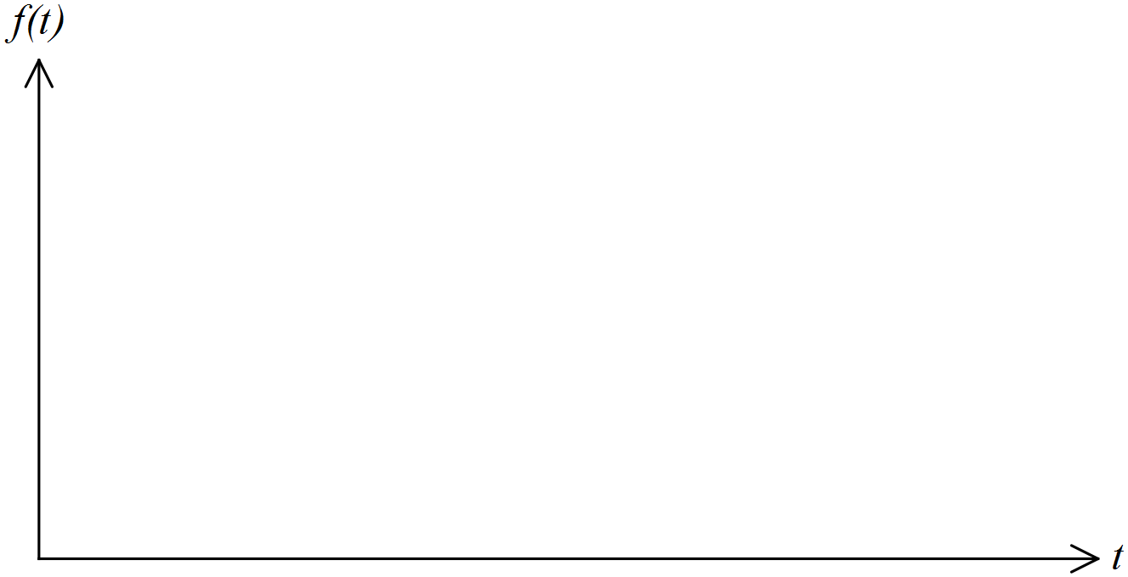

(b) Determine the probability that a randomly chosen interval between firings is

(i) at least seven minutes.

(ii) at least six minutes given that it is less than 10 minutes.

(c) (i) How many intervals will occur during the day?

(ii) Determine the probability that, on any one day of the festival, more than four intervals will be less than seven minutes long.

(d) Determine the value of  for which .

**Q5 (3 + 2 = 5 marks)**

A recent census found that 42% of the population were over 50 years of age.

(a) If the ages were recorded from a random sample of 300 people what is the probability that:

(i) the sample proportion of people over 50 was between 0.35 and 0.4.

(ii) more than 45% of the sample were over 50.

(b) Over what interval should the middle 50% of all sample proportions of people over 50 years of age lie for a sample size of 300.

**Q6 (1 + 3 + 2 = 6 marks)**

The WA Medical Association conducted a survey to estimate the proportion of adults in the Perth metropolitan area who had visited a GP in the previous year. Of 150 adults surveyed 96 stated that they had been to a doctor during the previous twelve months.

(a) State the sample proportion.

(b) Calculate a 95% confidence interval for the proportion of people in the Perth metropolitan area who had visited their local GP in the previous year and **interpret** your answer.

(c) It is decided that a smaller interval from part(b) is required. To achieve this result:

(i) The sample size could be (CIRCLE the correct adjustment below).

INCREASED or DECREASED

(i) The percentage used on the confidence interval could be (CIRCLE the correct adjustment below).

INCREASED or DECREASED

**Q7 (4 marks)**

A random variable *X* is normally distributed such that the mean is 6 times the standard deviation and the probability that *X* is greater than 21.5 is 0.231. Find the mean and standard deviation of *X*.